Oxfordshire RFU

Handbook for Oxfordshire
Knock-out Cup and Shield Competitions

2022/2023

Revision 1.0

The version of the handbook published at the following link is deemed to be the official version of the competition regulations:
https://www.oxfordshirerfu.com/competitions/senior-county-cup-and-shield/

Changes from 2021/22

Where | What
Document | Reformatted and reorganised to ORFU competitions standard.  Changes below refer to modifications to regulations from 2021/22 and will not reflect a move of regulation to a new section of the document.
1 | Addition of regulations for WhatsApp group and Covid-19
4.4 | Change in order of resolution in event of a draw
4.5 | Guidance added on match abandonment
4.10 | Explanation of what happens if a team withdraws from a competition.

1. Competition format
There are two separate competitions known as ‘The County Cup “and “The County Shield”. The competitions shall be organised by the Oxfordshire RFU Competitions Committee. Each will be a knock-out cup with the winner progressing to the next round.

Any Rugby Club within the Oxfordshire County boundaries, affiliated to, or allocated to the Oxfordshire RFU shall be eligible to enter in the competitions.

All matches in the competition shall be played under the Laws of Rugby Football and comply with the rules and regulations of the Rugby Football Union.

1.1 County Competitions Committee (the “CCC”) Coordinator
Your CCC Coordinator is: Jane Weaver (joint chair of competitions for Oxfordshire RFU)
Email: ORFUCompetitions@outlook.com
Mobile: 07808 950198
Address: Cadbold Farmhouse, Pillerton Priors, Warwickshire, CV35 0PQ

In addition to the CCC Coordinator the County Competitions Committee are:
Doug Bosley: 07775 508818
Jenny Bosley: 07742 732014
Paul Weaver: 07710 981481

1.2 WhatsApp group / GDPR
As a condition of entry each club must supply the mobile number of a team administrator or coach who will act as the focal point for the club and will be added to a WhatsApp group. This person will be responsible for reporting results or communicating other issues with fixtures (e.g., waterlogged pitches). The contact information should be sent to the CCC Coordinator above and this confirms permission for the number and name to be shared within the group under GDPR (in relation to these competitions and other county rugby matters only). The focal point may leave the group at any time, and this revokes the permission provided above. Should the focal point leave, the club must provide a replacement if still in the competition.

1.3 Potential Covid-19 regulation changes
If the RFU changes the regulations for play temporarily then that change will take precedence over these regulations. This will only be for the time that the RFU has issued that change and the CCC will confirm, as appropriate, how any Covid-19 modified regulations will be applied throughout the competition.

2. Player Eligibility
Club GMS registered players are eligible to play in the competitions. If there is any doubt as to the eligibility of one of its players a club may apply to the CCC for a ruling up to seven days before a game. Any infringement of this regulation may lead to the club being disqualified from the competition.

Non-League clubs must provide a squad list, including names and dates of birth, before the start of the competition each season. This list can be added to during the run of the competition each season.

2.3 Squads
In all rounds of competition, the following applies:
- Each team can consist of a squad of twenty players where all five replacements can be used. Each team must have five players in their total squad capable of playing in the front row. Rolling subs will be used in both competitions with a maximum of 10 player interchanges per team. Rolling Subs will be used as per RFU Regulation 13 Appendix 2.

- A player may play for only one club in the Oxfordshire Cup or Shield competitions (i.e., once a player has represented a club in either competition, he may not represent another club in either competition during the same season).

3. Referees and observers
Referees for all matches in the competitions shall be appointed by the Oxfordshire Referees Society (see also “Fixture date and time below”). The Society will also appoint touch judges for the semi-finals and finals. For all other matches each club shall provide a competent touch judge for the whole of the match. Replacements are not eligible to act as touch judges.

Wherever possible the CCC shall appoint an Official Observer for each of the matches in these competitions. The Observer can advise (if asked) on any related query to the respective competition regulations. It is the responsibility of the participating clubs to ensure that competition regulations are adhered to. If an official observer is not able to attend alternative arrangements will be made with the clubs participating in the game wherever possible.

4. Fixtures and game management

4.1 Draw
Prior to the start of the competition the CCC will organise the draw for each competition, ideally at the Oxfordshire RFU Annual General Meeting but as such time as is convenient. The exact structure of each competition will be defined by the number of teams entering. The first club drawn from each pair shall be deemed the home team unless otherwise agreed. In the Finals, home and away status will be decided alphabetically.

4.1.1 With 7 teams expressing interest there will be 3 rounds. There will be 3 matches in the first round (one bye) with the winners going to the Cup semi-final. The losers will go to the Plate semi-final where they will be joined by the best loser in the cup semi-final (based upon smallest points difference, if equal, most tries scored, is still equal, most conversions or finally a coin toss). A draw will be held before the first round and again for determining home/away in the semi-finals.
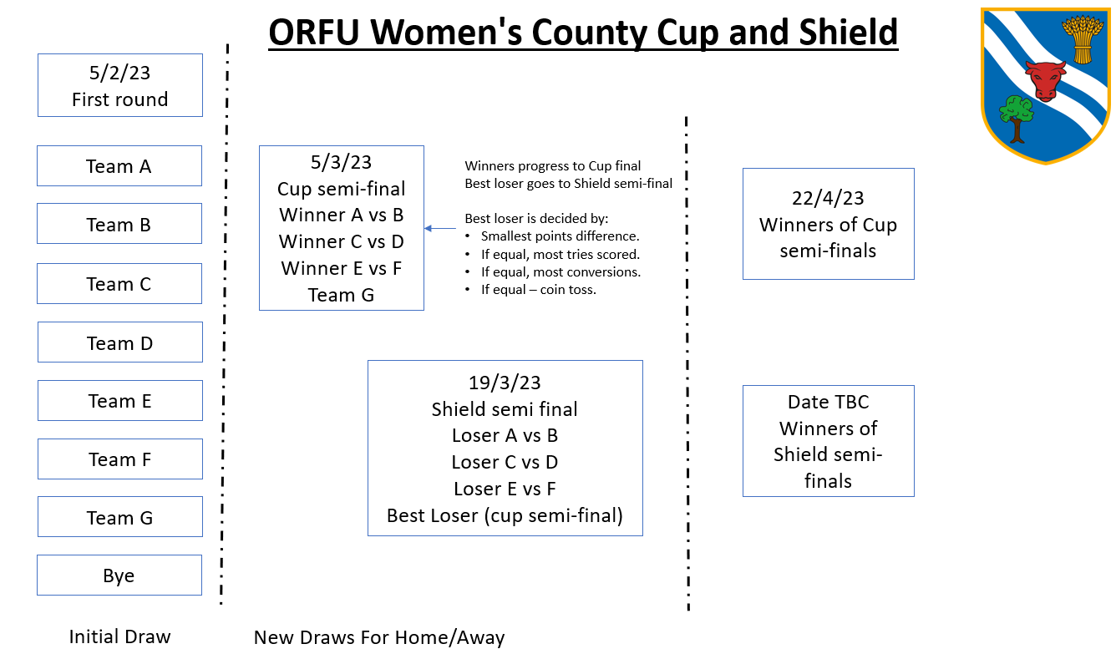

4.2 Venue
The venue for the match will be the normal 1st team pitch of the Home Club. In the event of a change of venue and the fixture is reversed then the away side on the day benefits if the game is a draw. If the venue is changed to a neutral ground, the original named home team remains the home team. If two clubs who use the same ground are both drawn as the home side in the same round, the guest club will be responsible for providing an alternative pitch. For its match the home team will be responsible for correctly and clearly marking the pitch and must make proper provision to ensure (except for the two touch judges and any county officials) all spectators, replacements and club officials are kept at a reasonable distance from the field of play. Team managers/coaching staff should remain within a clearly marked technical area. When a late decision as to the fitness of the ground for the playing of the match is necessary, the final decision will be with the match referee.

4.3 Draws at full time (non-finals)
In all rounds of the competitions (other than the final) if, after 40 minutes of play each way, the scores are level, the team which has scored the most tries shall go forward to the next round. If this does not produce a winner, the team which has scored the most goals from tries shall be the winner. If a winner is still not forthcoming, the visiting side will go forward to the next round.

4.4 Draws at full time (finals)
In any final if, after 40 minutes of play each way, the scores are level there will be a ‘sudden death’ play off. After tossing for choice of ends (away team calls), a further single period of ten minutes shall be played and the first team to score shall be declared the winner. If there is no score in this ten-minute period, then the team which has scored the most tries in the match shall be the winner. If this does not produce a winner, the team which scored the most goals from tries shall be the winner. If still equal the match shall then be decided by a toss of a coin (home team calls).

4.5 Postponement and match abandonment
If the ground conditions prevent a match from starting, or if a match is abandoned with less than 60 minutes played, the match will be declared void and re-arranged at a time and place decided by the CCC. If a match is abandoned after 60 minutes have been played, the score at that time will stand as the result. The referee and the county observer (at finals the CCC) are the sole judges as to the necessity for, and the time of abandoning a match. As guidance, it is expected that an on-field injury causing a break in play of more than 75 minutes (e.g., due to no other pitch being available) would be the minimum delay before voiding the match (unless it is clear earlier that play will not be able to continue).

If a final is abandoned, then it will be rescheduled to the start of the next season unless both teams agree to share the honours (in this case winners/losers medals will not be awarded). If only one team agrees to the reschedule then they will be deemed the winner.

4.6 Finals
In competition finals the CCC will be responsible for all match arrangements. The venues for the finals will be decided by the CCC and the finalists will be notified of the venues and kick off times in good time before the games.

4.7 Fixture date and time
The default time for matches to be played is the Sunday of the scheduled weekend with a 2.30pm kick off. However, both teams can mutually agree to play on the Saturday of that weekend or, if it should prove necessary, at any other time mutually agreed by both clubs and the CCC. Clubs are responsible for notifying the Referees Society of the day and time of the match, as soon as it is known and agreed, so a referee can be arranged. Also, clubs must advise the CCC at least 7 days prior, that everything is in place for the game to take place on the scheduled date. This is necessary so that an official county observer can be arranged to attend the game.

If both clubs cannot mutually agree to the day and time, then the game will be played on the designated Sunday at 2.30pm.

4.8 Club strips
In the event of clubs having similar colours, the AWAY team shall be responsible for changing its colours, subject to the satisfaction of the referee. Team jerseys should be numbered or lettered to ensure correct identification of all players and replacements during the match.

4.9 Matchday team sheets
At least 15 minutes before the kick off of each match, both clubs shall provide the county observer with a completed team sheet, identifying each player and their position and also the replacements for that match. The 5 players capable of playing front row must also be clearly marked with ‘FR’. It is highly recommended that electronic match cards in GMS are used by both teams: https://www.englandrugby.com/participation/running-your-club/game-management-system/electronic-match-card

4.10 Withdrawing from the competition/sanctions
Should a club choose to withdraw from the competition at any stage for any reason then the CCC will invite the club they beat in the previous round to play their next fixture. If that offer is declined, then the other club in the fixture gets a walkover win. Thus, if Club “A” beats Club “B” and is scheduled to play Club “C” in the next round but withdraws for whatever reason, Club “B” will be invited to play Club “C”. If Club “B” declines, then Club “C” progresses to the next round (or wins the competition).

The CCC must be informed (via email) as soon as reasonably possible of the intention to withdraw and the reason(s) why. Further, a club should contact the CCC by phone if acknowledgement of their email has not been received. Evidence of sending will not be accepted as proof of receipt.

If withdrawal occurs in the final round, then Club “A” are automatically excluded from entry into any Oxfordshire RFU adult competitions for 12 months (not just the ones described in this document). Should the excluded club wish to appeal they may do so at the Annual General Meeting of Oxfordshire RFU provided at least 2 weeks notice was withdrawal was given above. At that meeting consideration will be made for any mitigating circumstances previously documented.

5. Match Results & Publication
The result of each match must be “WhatsApp”ed to the CCC by the official observer (or home team if no observer) on conclusion of the game (and certainly within 24 hours). In the event of a dispute the match referee(s) will be contacted by the CCC and based upon the information provided the CCC decision will be final.

6. Trophies
It is the responsibility of all clubs that receive a trophy to make sure arrangements are made for the trophy to be returned, engraved with their win, to the CCC in time for the following seasons finals.

7. Disputes
Any matters of dispute or any transgressions to these regulations must be communicated, in writing (email accepted as per section 1), to the CCC within four days of match completion. The CCC decision will be final and binding, whether the matter is explicitly provided for in these regulations or not.

Amended: 30th September 2022

