OXFORDSHIRE RFU STRATEGIC PLAN 2025 – 2028



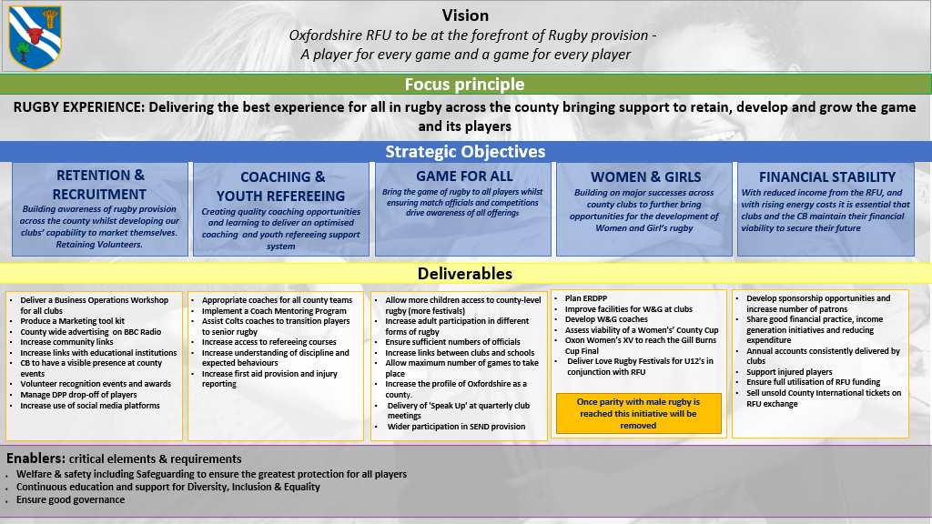
Strategic Objective 1: Recruitment & Retention
Building awareness of rugby provision across the county whilst developing our clubs' capability in marketing themselves.
Delivering ongoing retention of volunteers
Season
Actions | Success Criteria | Cost | Responsible | Date | 25 | 26 | 27
1. To plan and deliver a Business Operations workshop for all Clubs to enable them to attract Players & Volunteers e.g. attending Community events, Freshers' week etc. | 60+% of Clubs attend (and implement some of the practices presented to them)  Provided by RFU funded workshop |  | HB/NV | Apr 26
2. To maintain a relationship with Radio Oxford so that there are monthly broadcasts promoting Clubs, their rugby matches and competitions | A relationship is maintained with Radio Oxford's Sports reporter. A rota is compiled so that all clubs get some promotion throughout the season | Nil | TW
3. To fully integrate communications platform | All social media platforms to be used weekly to promote rugby. Six-month player survey | TW/HH to advise | TW
4. Liaise with Development Player Pathways (DPP) over the rejection of players' process | Robust communications between DPP leads and Club contact | Nil | FW/LF
5. Club Volunteers are recognised and rewarded | Volunteers invited to Annual Awards Lunch | £1,097 | GO | May 26
6. Establish relationships between Schools Relationship Manager (SRM)/ County Schools Union (CSU) & Constituent Body (CB) | Work with all stakeholders to build a school’s community which in long term will underpin transitions into club rugby. Develop communication between state schools and independent schools. Organise a county competition at levels where there is no cup or plate option | £1,000? for finals, medals catering  JW to provide breakdown & Quotes | JW schools  /LC | May 27
7. Adult Male social rugby | Explore and establish social adult male playing opportunities for lapsed/new players e.g. Friday Night Lights once a month using Game On/BaBas/Pitch up and Play. Consult with lower league team captains to canvas an appropriate offer, with support from RFU Club Development Officer (CDO) | SM/HH to advise | SM/DL | To be provided by SM/DL
Overall Impact/ Total Cost | All Club teams continue to exist and fulfil 90% of their fixtures

Strategic Objective 2: Coaching & Youth Refereeing for high quality rugby
Creating quality coaching opportunities and learning to deliver an optimised coaching and youth refereeing support system
Season
Actions | Success Criteria | Cost | Responsible | Date | 25 | 26 | 27
1. FW to meet all Clubs' Age Grade Rugby leads to assess coaching levels/needs and encourage player nomination. Train more coaches in Coach the Coaches sessions in 5 areas | Coach the Coaches sessions are run in 5 locations. Enough players are nominated for County games to take place |  | SB | Start Dec 25
2. Colts coaches are supported in their skills development until January, then in transition to adult rugby from February | 10% more Colts players transition into adult rugby at their respective clubs | Nil | SB/FW
3. Youth Match Official/Females Match Official recruitment and support | Work in collaboration with Referees Society to support YMO/FMO recruitment and retention. Targeted communications to those who have recently completed Introduction to Refereeing (ITR) course to invite them to Referee Society training evening. Potential to link with SRM/CSU to support school events |  | PB/RC/D Haggart
4a. Appoint and train more disciplinary panel members  4b. Disciplinary County Workshop | Clubs report red card cases asap and pay fees. Disciplinary hearings get no successful appeals  Training of disciplinary officers to support county | Nil | RW  DH
5. Engage and develop Club Coaching Coordinators and Club Coaches | SB to hold CCC forum in conjunction with Nick Todd, to canvas and develop CB coach education offer to compliment RFU coach ed calendar e.g. guest coach’s evenings, coaching conference etc |  | SB
6. To provide First aid training for 2025/26 Adult rugby | All Clubs have sufficient First aiders for 25/26 | TH/HH to provide | TH
7. To hold Age Grade Rugby (AGR) forums x 4 each season | With support from RFU Club Developer, hold forums – mix of virtual and F2F to ensure AGR leads informed on current processes, opportunities, funding and events |  | FW/LF
8. To supply all clubs & county teams with the Proactive App to record/report injuries | 17 Clubs & CB supplied with App @ £50 p.a. |  | TH
Overall Impact/Total Cost | The quality of coaching/refereeing improves, so player enjoyment and retention increase

Strategic Objective 3: A Game for All
Bring the game of rugby to all players whilst ensuring match officials and competitions drive awareness of all offerings
Season
Actions | Success Criteria | Cost | Responsible | Date | 25 | 26 | 27
1. Increase participation in different forms of rugby over the next 3 years | Organise/ensure that the following are offered by clubs or the CB  Walking/T1/Wheelchair rugby  Club grants to organise T1 series e.g. summer T1 series – clubs apply for £200 to support a summer series or festival and report back on where grant was spent and how successful initiative was  CB annual walking rugby festival |  | DR
2. Wider participation in our SEND provision for 2025-26 | 1+ more clubs offer SEND Increase funding by sponsorship - £2+k  Get further support & funding from OCC  Offer (more) resources & courses for clubs  Provide a Mental Health course for coaches  Increase the Katie Peel Festival participation by 2 teams | 1,500 | DR
3. Support and education content and courses for coaches and match officials in SEND delivery | Ensure coaches and match officials (CMOs) have access to relevant educational support and resources |  | GO & DR
4. Further develop links between clubs and schools | Intro meeting with CSU and SRM, facilitate links between clubs and schools receiving delivery and appoint a point of contact for SRM to feed into the CB  FW – CB U18 head coach has  SRM to feed into the CB been speaking to schools – will get a update | Nil | JW/LC/FW
5. Increase the profile of Oxfordshire as a County | Enter Adult Male, Women’s teams into the County Championship  Establish U/20s squad earlier in the season |  | DB & CW  FW(U20)
6. Provision of ‘Speak Up’ campaign at quarterly club meetings | Delivery of ‘Speak Up’ at least one quarterly Club Meeting |  | GO/DR
7. Facilities support to clubs. To promote facility audit to clubs | Aim for 90% completion rate. Work with RFU facility team to prioritise club needs and identify clubs for support. Further support clubs with facility grants |  | PB/RW/Jay Bowers
8. Rugby Safe –  Supporting clubs with first aid provision and injury reporting  Engage and support club Rugby Safe leads | Regular updates via email/WhatsApp/forums  2 x F2F forums; online virtual catch-up calls in between |  | TH/SC
9. Safeguarding –  Provide safeguarding courses to clubs to increase low percentage of training covered in the CB  Support club Safeguarding Officers through regular forums; email / WhatsApp communication/ audits  To appoint and train a team of Safeguarding CBSMs to support, promote and develop safeguarding across Oxfordshire RFU  To review systems and processes in place linked to Safeguarding to adapt to a team working across Safeguarding | Through CSO forums/groups, encourage CSOs to identify need by club training reports and coordinate locations to book courses  A fully trained team of 2-3 CBSMs will be in place, who will actively take part in network opportunities |  | TH/SC
Overall Impact/Total Costs | Increase in the number of players of all ages, abilities and gender

Strategic Objective 4: Women & Girls Rugby
Building on major successes across county Clubs to bring further opportunities for the development of W&G rugby
We anticipate that this Strategic Objective will be achieved within 3 years and will be removed and integrated across the other objectives
Season
Actions | Success Criteria | Cost | Responsible | Date | 25 | 26 | 27
- Love Rugby Festivals U12 | Work with RFU staff to deliver Love Rugby festivals throughout the season for U12 girls x 4 events |  | NV/LF
- Deliver quarterly W&G forums for Clubs with RFU CD to ensure clubs are aware of all opportunities and current information | 3 or more delivered with 50% attendance on average |  | LF/CW/DL
3. Maintain the new ERDPP for our AGR Girls section | RFU grant of £8k given and plan in place | £8,000: | LF/CW
4. Improve W & G Referee's changing facilities by offering 4 clubs grants up to £500 | No complaints received from Women & Girls match officials | £2,000 | RW/DH
4. To provide more coaching opportunities for W&G rugby and to develop more women coaches | Work with SB to offer coaching programmes  County coaches to support club coach development |  | CW/SB & Clubs
5. To assess the viability of a Women's Oxon County Cup and implement | An annual Women's County Cup and Shield Competition is established |  | CW, SB, SM
7. To provide IWS clubs with the opportunity to have development playing opportunities and competitions within Oxfordshire | Offer competition and development days for all IWS Teams and lower-level teams | TBC | RW/LG
8. To support and encourage the teams with the IWS to develop and join NC3 during the next three years | To have at least two clubs join or rejoin leagues from IWS by the end of 2025/2026 season  In 2027 the majority of IWS Clubs to be playing in leagues |  | CW
9. To reach the Gill Burns Cup Final | Oxon Women's XV achieve a position in the final during the next 3 seasons (Strategy Objective 3.5 above) |  | CW
10. Increase Board Member attendance at W&G games |  | Nil | All CB Board Members
11. To establish a county development squad | Development squad to be developed and playing fixtures in 2025/2026 season |  | CW/LG
Overall Impact/ Total Cost | There is a continued increase in the number of W&G playing, coaching and refereeing.

Strategic Objective 5: Financial Stability
With reduced income from the RFU it is essential that clubs and the CB maintain their financial viability to secure their future
Season
Actions | Success Criteria | Income | Responsible | Date | 25 | 26 | 27
1. Sponsorship opportunities to be further explored | At least one major sponsor on board for 2025/26 season increasing financial support available for clubs | Target £5,000 | GC/HH
2. Develop more Patrons for ORFU | Patron numbers increase by 50% (from 8 to 12) | £1,040 | HH/KE
3. Clubs to share good practices in raising income and reducing expenditure | Promote relevant RFU webinars and VAT expert | Nil | HH
4. Annual Accounts are submitted by Clubs to CB | All clubs annual accounts received by 31/12/25 deadline | Nil | HH | 31st Dec
5. County International Tickets not sold | Sell on RFU exchange for the standard price (£2,200 for Autumn internationals 2025 and Six Nations 2026 missed income) | £2,200 | HH/KE
6. Ensure County receives all eligible RFU funding | Deliver and report against funding criteria | £30,143 | HH/all | Oct 25
Overall Impact | Maximum support to clubs to help them maintain operational / financial viability

Total Annual Cost of Strategic Plan
2025-2026 | 2026-2027 | 2027-2028
TBC | TBC | TBC

